Assignment-2

Data Visualization and Pre-processing

|  |  |
| --- | --- |
| Assignment Date | October 4 |
| Student Name | R.Bensiya shmaily |
| Student Roll Number | 822019104003 |
| Maximum Mark | 2 Mark |

**A - Load the dataset**

In [41]:

**import** pandas **as** pd

df**=**pd**.**read_csv("Churn_Modelling.csv") *# import dataset*

print(df)

RowNumber CustomerId Surname CreditScore Geography Gender Age \

0 1 15634602 Hargrave 619 France Female 42

1 2 15647311 Hill 608 Spain Female 41

2 3 15619304 Onio 502 France Female 42

3 4 15701354 Boni 699 France Female 39

4 5 15737888 Mitchell 850 Spain Female 43

... ... ... ... ... ... ... ...

9995 9996 15606229 Obijiaku 771 France Male 39

9996 9997 15569892 Johnstone 516 France Male 35

9997 9998 15584532 Liu 709 France Female 36

9998 9999 15682355 Sabbatini 772 Germany Male 42

9999 10000 15628319 Walker 792 France Female 28

Tenure Balance NumOfProducts HasCrCard IsActiveMember \

0 2 0.00 1 1 1

1 1 83807.86 1 0 1

2 8 159660.80 3 1 0

3 1 0.00 2 0 0

4 2 125510.82 1 1 1

... ... ... ... ... ...

9995 5 0.00 2 1 0

9996 10 57369.61 1 1 1

9997 7 0.00 1 0 1

9998 3 75075.31 2 1 0

9999 4 130142.79 1 1 0

EstimatedSalary Exited

0 101348.88 1

1 112542.58 0

2 113931.57 1

3 93826.63 0

4 79084.10 0

... ... ...

9995 96270.64 0

9996 101699.77 0

9997 42085.58 1

9998 92888.52 1

9999 38190.78 0

[10000 rows x 14 columns]

# B - Perform Below Visualizations.

# 1. Univarient Analysis

# 1. Univarient Analysis

## There are three ways to perform univarient analysis

## i) Summary statistics

In [42]:

*# Summary statistics*

**import** pandas **as** pd

df**=**pd**.**read_csv("Churn_Modelling.csv")

*#mean of CreditScore*

M**=**df['CreditScore']**.**mean()

*#median of CreditScore*

Me**=**df['CreditScore']**.**median()

*# standard deviation of CreditScore*

std **=** df['CreditScore']**.**std()

print("mean value of CreditScore is {}"**.**format(M))

print("median value of CreditScore is {}"**.**format(Me))

print("Standard deviation of CreditScore is {}"**.**format(std))

mean value of CreditScore is 650.5288

median value of CreditScore is 652.0

Standard deviation of CreditScore is 96.65329873613061

## ii) Frequency table

*#Frequency table*

**import** pandas **as** pd

df**=**pd**.**read_csv("Churn_Modelling.csv")

*#frequency table for age*

ft**=**df['Age']**.**value_counts()

print("Frequency table for Age is given below")

print("{}"**.**format(ft))

Frequency table for Age is given below

37 478

38 477

35 474

36 456

34 447

...

92 2

82 1

88 1

85 1

83 1

Name: Age, Length: 70, dtype: int64

## iii) Charts

In [44]:

*#Chart*

**import** matplotlib.pyplot **as** plt

dfs **=** df**.**head() *# print first five table from top*

print(dfs)

*#box plot for Balance column*

*#box plot for Balance column*

dfs**.**boxplot(column**=**"Balance",grid**=False**,color**=**"red")

plt**.**title('Box plot')

RowNumber CustomerId Surname CreditScore Geography Gender Age \

0 1 15634602 Hargrave 619 France Female 42

1 2 15647311 Hill 608 Spain Female 41

2 3 15619304 Onio 502 France Female 42

3 4 15701354 Boni 699 France Female 39

4 5 15737888 Mitchell 850 Spain Female 43

Tenure Balance NumOfProducts HasCrCard IsActiveMember \

0 2 0.00 1 1 1

1 1 83807.86 1 0 1

2 8 159660.80 3 1 0

3 1 0.00 2 0 0

4 2 125510.82 1 1 1

EstimatedSalary Exited

0 101348.88 1

1 112542.58 0

2 113931.57 1

3 93826.63 0

4 79084.10 0

Out[44]:

Text(0.5, 1.0, 'Box plot')

*#box plot for Balance column*

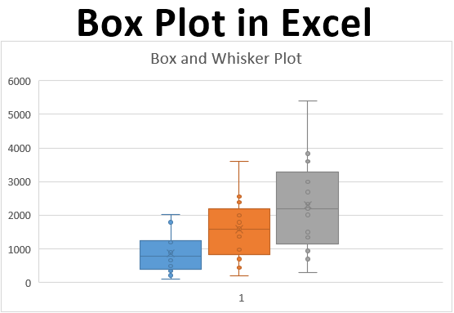

*Histogram for Credit Score*

df**.**hist(column**=**"CreditScore" ,grid**=True**, edgecolor **=**'black', color **=**'red')

plt**.**title('Histogram')

Out[45]:

Text(0.5, 1.0, 'Histogram')

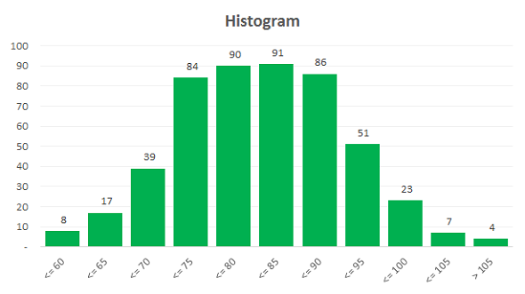

In [46]:

*# Density curve*

**import** seaborn **as** sns *#statistical data visualization*

sns**.**kdeplot(df['CreditScore'])

plt**.**title('Density Curve')

Out[46]:

Text(0.5, 1.0, 'Density Curve')

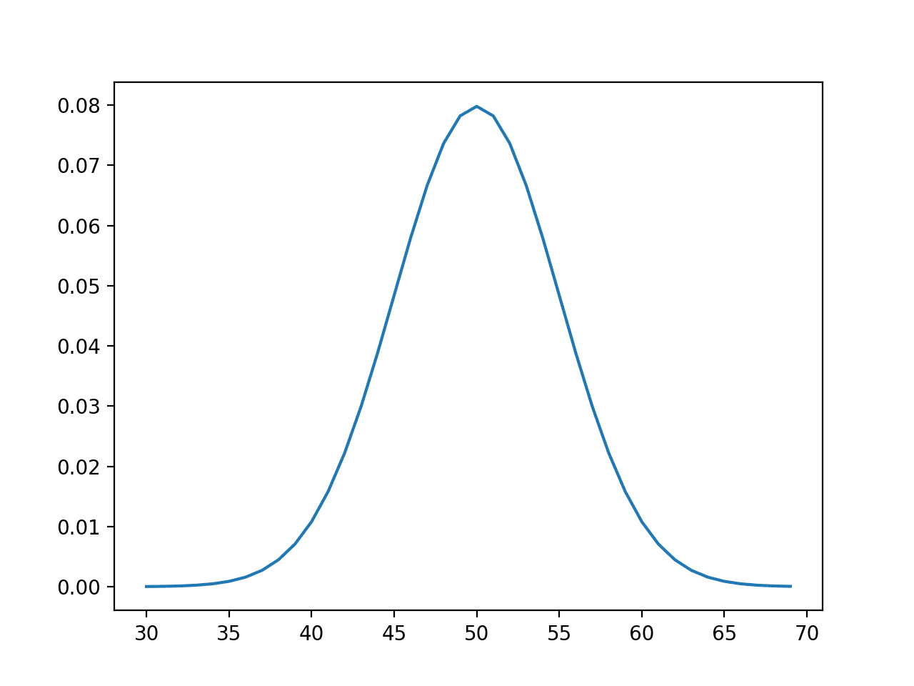

# 2. Bi - Variate Analysis

## There are three common ways to perform bivariate analysis:

## i. Scatterplots

In [47]:

**import** matplotlib.pyplot **as** plt *# library for charts*

dfs1 **=** df**.**head(20)

plt**.**scatter(dfs1**.**CreditScore,dfs1**.**Balance)

plt**.**title('Scatterplots-- Banking')

plt**.**xlabel("CreditScore")

plt**.**ylabel("Balance")

Out[47]:

Text(0, 0.5, 'Balance')

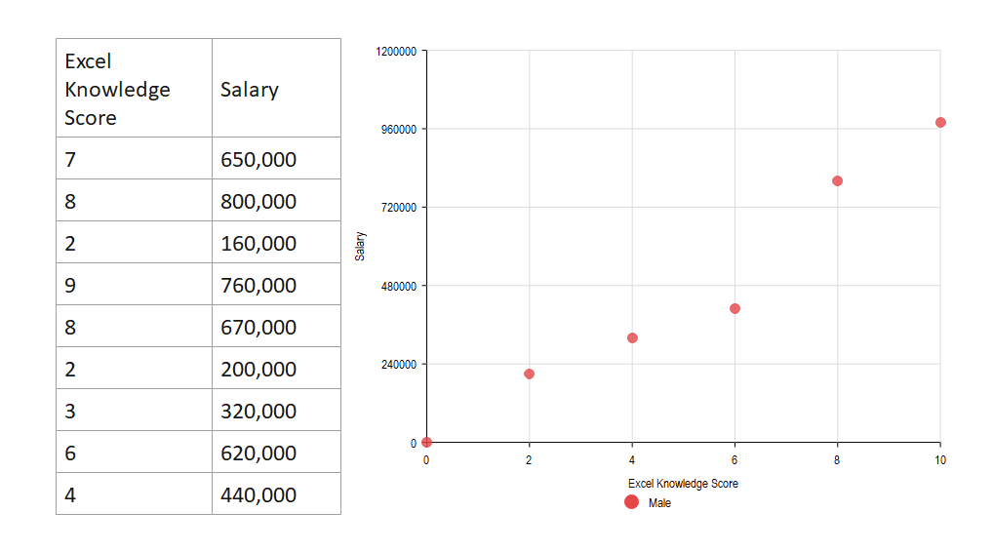

## ii.Correlation Coefficient

In [48]:

df**.**corr()

Out[48]:

|  | **RowNumber** | **CustomerId** | **CreditScore** | **Age** | **Tenure** | **Balance** | **NumOfProducts** | **HasCrCard** | **IsActiveMember** | **EstimatedSalary** | **Exited** |
| --- | --- | --- | --- | --- | --- | --- | --- | --- | --- | --- | --- |
| **RowNumber** | 1.000000 | 0.004202 | 0.005840 | 0.000783 | -0.006495 | -0.009067 | 0.007246 | 0.000599 | 0.012044 | -0.005988 | -0.016571 |
| **CustomerId** | 0.004202 | 1.000000 | 0.005308 | 0.009497 | -0.014883 | -0.012419 | 0.016972 | -0.014025 | 0.001665 | 0.015271 | -0.006248 |
| **CreditScore** | 0.005840 | 0.005308 | 1.000000 | -0.003965 | 0.000842 | 0.006268 | 0.012238 | -0.005458 | 0.025651 | -0.001384 | -0.027094 |
| **Age** | 0.000783 | 0.009497 | -0.003965 | 1.000000 | -0.009997 | 0.028308 | -0.030680 | -0.011721 | 0.085472 | -0.007201 | 0.285323 |
| **Tenure** | -0.006495 | -0.014883 | 0.000842 | -0.009997 | 1.000000 | -0.012254 | 0.013444 | 0.022583 | -0.028362 | 0.007784 | -0.014001 |
| **Balance** | -0.009067 | -0.012419 | 0.006268 | 0.028308 | -0.012254 | 1.000000 | -0.304180 | -0.014858 | -0.010084 | 0.012797 | 0.118533 |
| **NumOfProducts** | 0.007246 | 0.016972 | 0.012238 | -0.030680 | 0.013444 | -0.304180 | 1.000000 | 0.003183 | 0.009612 | 0.014204 | -0.047820 |
| **HasCrCard** | 0.000599 | -0.014025 | -0.005458 | -0.011721 | 0.022583 | -0.014858 | 0.003183 | 1.000000 | -0.011866 | -0.009933 | -0.007138 |
| **IsActiveMember** | 0.012044 | 0.001665 | 0.025651 | 0.085472 | -0.028362 | -0.010084 | 0.009612 | -0.011866 | 1.000000 | -0.011421 | -0.156128 |
| **EstimatedSalary** | -0.005988 | 0.015271 | -0.001384 | -0.007201 | 0.007784 | 0.012797 | 0.014204 | -0.009933 | -0.011421 | 1.000000 | 0.012097 |
| **Exited** | -0.016571 | -0.006248 | -0.027094 | 0.285323 | -0.014001 | 0.118533 | -0.047820 | -0.007138 | -0.156128 | 0.012097 | 1.000000 |

## iii. Simple Linear Regression

In [49]:

**import** statsmodels.api **as** sm

*# response variable*

y **=** df['CreditScore']

*# explanatory variable*

x **=** df[['Balance']]

*#add constant to predictor variables*

x **=** sm**.**add_constant(x)

*#fit linear regression model*

model **=** sm**.**OLS(y, x)**.**fit()

*#view model summary*

print(model**.**summary())

OLS Regression Results

==============================================================================

Dep. Variable: CreditScore R-squared: 0.000

Model: OLS Adj. R-squared: -0.000

Method: Least Squares F-statistic: 0.3929

Date: Sun, 25 Sep 2022 Prob (F-statistic): 0.531

Time: 13:06:05 Log-Likelihood: -59900.

No. Observations: 10000 AIC: 1.198e+05

Df Residuals: 9998 BIC: 1.198e+05

Df Model: 1

Covariance Type: nonrobust

==============================================================================

coef std err t P>|t| [0.025 0.975]

-----------------------------------------------------------------------------

const 649.7861 1.529 424.948 0.000 646.789 652.783

Balance 9.71e-06 1.55e-05 0.627 0.531 -2.07e-05 4.01e-05

==============================================================================

Omnibus: 132.594 Durbin-Watson: 2.014

Prob(Omnibus): 0.000 Jarque-Bera (JB): 84.114

Skew: -0.072 Prob(JB): 5.43e-19

Kurtosis: 2.574 Cond. No. 1.56e+05

==============================================================================

Notes:

[1] Standard Errors assume that the covariance matrix of the errors is correctly specified.

[2] The condition number is large, 1.56e+05. This might indicate that there are

strong multicollinearity or other numerical problems.

**3. Multi - Variate Analysis**

In [126]:

**import** pandas **as** pd

**import** numpy **as** np

**import** matplotlib.pyplot **as** plt

**import** seaborn **as** sns

### i. A Matrix Scatterplot

### ii. A Scatterplot with the Data Points Labelled by their Group

### iii. A Profile Plot

### iv. Calculating Summary Statistics for Multivariate Data

### v. Means and Variances Per Group

### vi. Between-groups Variance and Within-groups Variance for a Variable

### vii. Between-groups Covariance and Within-groups Covariance for Two Variables

### viii. Calculating Correlations for Multivariate Data

### ix. Standardising Variables

### x. Standardising Variables

In [127]:

df**=**sns**.**catplot(x**=**"Geography",y**=**"EstimatedSalary",hue**=**"Gender",kind**=**"swarm",data**=**df)

print(df)

/home/lokesh/anaconda3/lib/python3.9/site-packages/seaborn/categorical.py:1296: UserWarning: 80.8% of the points cannot be placed; you may want to decrease the size of the markers or use stripplot.

warnings.warn(msg, UserWarning)

/home/lokesh/anaconda3/lib/python3.9/site-packages/seaborn/categorical.py:1296: UserWarning: 62.1% of the points cannot be placed; you may want to decrease the size of the markers or use stripplot.

warnings.warn(msg, UserWarning)

/home/lokesh/anaconda3/lib/python3.9/site-packages/seaborn/categorical.py:1296: UserWarning: 62.6% of the points cannot be placed; you may want to decrease the size of the markers or use stripplot.

warnings.warn(msg, UserWarning)

## 4. Perform descriptive statistics on the dataset.

In [52]:

*#load data set into ld*

ld**=** pd**.**read_csv("Churn_Modelling.csv")

five **=** ld**.**head() *#for print first five rows*

In [53]:

*# information about used data set*

ld**.**info()

RangeIndex: 10000 entries, 0 to 9999

Data columns (total 14 columns):

# Column Non-Null Count Dtype

--- ------ -------------- -----

0 RowNumber 10000 non-null int64

1 CustomerId 10000 non-null int64

2 Surname 10000 non-null object

3 CreditScore 10000 non-null int64

4 Geography 10000 non-null object

5 Gender 10000 non-null object

6 Age 10000 non-null int64

7 Tenure 10000 non-null int64

8 Balance 10000 non-null float64

9 NumOfProducts 10000 non-null int64

10 HasCrCard 10000 non-null int64

11 IsActiveMember 10000 non-null int64

12 EstimatedSalary 10000 non-null float64

13 Exited 10000 non-null int64

dtypes: float64(2), int64(9), object(3)

memory usage: 1.1+ MB

**.**describe() *#description of the data in the Dataset*

Out [54]:

|  | **RowNumber** | **CustomerId** | **CreditScore** | **Age** | **Tenure** | **Balance** | **NumOfProducts** | **HasCrCard** | **IsActiveMember** | **EstimatedSalary** | **Exited** |
| --- | --- | --- | --- | --- | --- | --- | --- | --- | --- | --- | --- |
| **count** | 10000.00000 | 1.000000e+04 | 10000.000000 | 10000.000000 | 10000.000000 | 10000.000000 | 10000.000000 | 10000.00000 | 10000.000000 | 10000.000000 | 10000.000000 |
| **mean** | 5000.50000 | 1.569094e+07 | 650.528800 | 38.921800 | 5.012800 | 76485.889288 | 1.530200 | 0.70550 | 0.515100 | 100090.239881 | 0.203700 |
| **std** | 2886.89568 | 7.193619e+04 | 96.653299 | 10.487806 | 2.892174 | 62397.405202 | 0.581654 | 0.45584 | 0.499797 | 57510.492818 | 0.402769 |
| **min** | 1.00000 | 1.556570e+07 | 350.000000 | 18.000000 | 0.000000 | 0.000000 | 1.000000 | 0.00000 | 0.000000 | 11.580000 | 0.000000 |
| **25%** | 2500.75000 | 1.562853e+07 | 584.000000 | 32.000000 | 3.000000 | 0.000000 | 1.000000 | 0.00000 | 0.000000 | 51002.110000 | 0.000000 |
| **50%** | 5000.50000 | 1.569074e+07 | 652.000000 | 37.000000 | 5.000000 | 97198.540000 | 1.000000 | 1.00000 | 1.000000 | 100193.915000 | 0.000000 |
| **75%** | 7500.25000 | 1.575323e+07 | 718.000000 | 44.000000 | 7.000000 | 127644.240000 | 2.000000 | 1.00000 | 1.000000 | 149388.247500 | 0.000000 |
| **max** | 10000.00000 | 1.581569e+07 | 850.000000 | 92.000000 | 10.000000 | 250898.090000 | 4.000000 | 1.00000 | 1.000000 | 199992.480000 | 1.000000 |

**5. Handle the Missing values.**

ld**.**isnull()**.**any()

Out[56]:

RowNumber False

CustomerId False

Surname False

CreditScore False

Geography False

Gender False

Age False

Tenure False

Balance False

NumOfProducts False

HasCrCard False

IsActiveMember False

EstimatedSalary False

Exited False

dtype: bool

In [58]:

ld**.**isnull()**.**sum()

Out[58]:

RowNumber 0

CustomerId 0

Surname 0

CreditScore 0

Geography 0

**6. Find the outliers and replace the outliers**

In [73]:

*#occurence of outliers*

ld1**=** pd**.**read_csv("Churn_Modelling.csv")

sns**.**boxplot(ld1**.**CreditScore)

/home/lokesh/anaconda3/lib/python3.9/site-packages/seaborn/_decorators.py:36: FutureWarning: Pass the following variable as a keyword arg: x. From version 0.12, the only valid positional argument will be `data`, and passing other arguments without an explicit keyword will result in an error or misinterpretation.

warnings.warn(

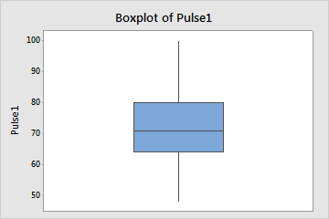

*Use Mean Detection and Nearest Fill Methods - Outliers*

Q1**=** ld1**.**CreditScore**.**quantile(0.25)

Q3**=**ld1**.**CreditScore**.**quantile(0.75)

IQR**=**Q3**-**Q1

upper_limit **=**Q3 **+** 1.5**\***IQR

lower_limit **=**Q1 **-** 1.5**\***IQR

ld1['CreditScore'] **=** np**.**where(ld1['CreditScore']**>**upper_limit,30,ld1['CreditScore'])

sns**.**boxplot(ld1**.**CreditScore)

/home/lokesh/anaconda3/lib/python3.9/site-packages/seaborn/_decorators.py:36: FutureWarning: Pass the following variable as a keyword arg: x. From version 0.12, the only valid positional argument will be `data`, and passing other arguments without an explicit keyword will result in an error or misinterpretation.

warnings.warn(



**7. Check for Categorical columns and perform encoding.**

In [77]:

ld1**.**head(5)

Out[77]:

|  | **RowNumber** | **CustomerId** | **Surname** | **CreditScore** | **Geography** | **Gender** | **Age** | **Tenure** | **Balance** | **NumOfProducts** | **HasCrCard** | **IsActiveMember** | **EstimatedSalary** | **Exited** |
| --- | --- | --- | --- | --- | --- | --- | --- | --- | --- | --- | --- | --- | --- | --- |
| **0** | 1 | 15634602 | Hargrave | 619 | France | 0 | 42 | 2 | 0.00 | 1 | 1 | 1 | 101348.88 | 1 |
| **1** | 2 | 15647311 | Hill | 608 | Spain | 0 | 41 | 1 | 83807.86 | 1 | 0 | 1 | 112542.58 | 0 |
| **2** | 3 | 15619304 | Onio | 502 | France | 0 | 42 | 8 | 159660.80 | 3 | 1 | 0 | 113931.57 | 1 |
| **3** | 4 | 15701354 | Boni | 699 | France | 0 | 39 | 1 | 0.00 | 2 | 0 | 0 | 93826.63 | 0 |
| **4** | 5 | 15737888 | Mitchell | 850 | Spain | 0 | 43 | 2 | 125510.82 | 1 | 1 | 1 | 79084.10 | 0 |

In [75]:

*#label encoder*

**from** sklearn.preprocessing **import** LabelEncoder

le**=**LabelEncoder()

ld1**.**Gender**=** le**.**fit_transform(ld1**.**Gender)

ld1**.**head(5)

| **wNumber** | **CustomerId** | **Surname** | **CreditScore** | **Geography** | **Gender** | **Age** | **Tenure** | **Balance** | **NumOfProducts** | **HasCrCard** | **IsActiveMember** | **EstimatedSalary** | **Exited** |
| --- | --- | --- | --- | --- | --- | --- | --- | --- | --- | --- | --- | --- | --- |
| **0** | 1 | 15634602 | Hargrave | 619 | France | 0 | 42 | 2 | 0.00 | 1 | 1 | 1 | 101348.88 | 1 |
| **1** | 2 | 15647311 | Hill | 608 | Spain | 0 | 41 | 1 | 83807.86 | 1 | 0 | 1 | 112542.58 | 0 |
| **2** | 3 | 15619304 | Onio | 502 | France | 0 | 42 | 8 | 159660.80 | 3 | 1 | 0 | 113931.57 | 1 |
| **3** | 4 | 15701354 | Boni | 699 | France | 0 | 39 | 1 | 0.00 | 2 | 0 | 0 | 93826.63 | 0 |
| **4** | 5 | 15737888 | Mitchell | 850 | Spain | 0 | 43 | 2 | 125510.82 | 1 | 1 | 1 | 79084.10 | 0 |

In [76]:

*#one hot encoding*

ld1_main**=**pd**.**get_dummies(ld1,columns**=**['Geography'])

ld1_main**.**head()

Out[76]:

|  | **RowNumber** | **CustomerId** | **Surname** | **CreditScore** | **Gender** | **Age** | **Tenure** | **Balance** | **NumOfProducts** | **HasCrCard** | **IsActiveMember** | **EstimatedSalary** | **Exited** | **Geography_France** | **Geography_Germany** | **Geography_Spain** |
| --- | --- | --- | --- | --- | --- | --- | --- | --- | --- | --- | --- | --- | --- | --- | --- | --- |
| **0** | 1 | 15634602 | Hargrave | 619 | 0 | 42 | 2 | 0.00 | 1 | 1 | 1 | 101348.88 | 1 | 1 | 0 | 0 |
| **1** | 2 | 15647311 | Hill | 608 | 0 | 41 | 1 | 83807.86 | 1 | 0 | 1 | 112542.58 | 0 | 0 |  |  |

**8. Split the data into dependent and independent variables.**

In [85]:

*#Splitting the Dataset into the Independent Feature Matrix*

df**=**pd**.**read_csv("Churn_Modelling.csv")

X **=** df**.**iloc[:, :**-**1]**.**values

print(X)

[[1 15634602 'Hargrave' ... 1 1 101348.88]

[2 15647311 'Hill' ... 0 1 112542.58]

[3 15619304 'Onio' ... 1 0 113931.57]

...

[9998 15584532 'Liu' ... 0 1 42085.58]

[9999 15682355 'Sabbatini' ... 1 0 92888.52]

[10000 15628319 'Walker' ... 1 0 38190.78]]

In [86]:

*#Extracting the Dataset to Get the Dependent Vector*

Y **=** df**.**iloc[:, **-**1]**.**values

print(Y)

1 0 1 ... 1 1 0]

**9. Scale the independent variables**

In [96]:

w **=** df**.**head()

q **=** w[['Age','Balance','EstimatedSalary']] *#spliting the dataset into measureable values*

q

Out[96]:

|  | **Age** | **Balance** | **EstimatedSalary** |
| --- | --- | --- | --- |
| **0** | 42 | 0.00 | 101348.88 |
| **1** | 41 | 83807.86 | 112542.58 |
| **2** | 42 | 159660.80 | 113931.57 |
| **3** | 39 | 0.00 | 93826.63 |
| **4** | 43 | 125510.82 | 79084.10 |

In [101]:

**from** sklearn.preprocessing **import** scale *# library for scallling*

**from** sklearn.preprocessing **import** MinMaxScaler

mm **=** MinMaxScaler()

x_scaled **=** mm**.**fit_transform(q)

x_scaled

rray([[0.75 , 0. , 0.63892099],

[0.5 , 0.52491194, 0.96014087],

[0.75 , 1. , 1. ],

[0. , 0. , 0.42305883],

[1. , 0.78610918, 0. ]])

In [103]:

**from** sklearn.preprocessing **import** StandardScaler

sc **=** StandardScaler()

x_ss **=** sc**.**fit_transform(q)

x_ss Out[103]:

array([[ 0.44232587, -1.13763618, 0.09337626],

[-0.29488391, 0.15434425, 0.96285595],

[ 0.44232587, 1.32369179, 1.07074687],

[-1.76930347, -1.13763618, -0.49092058],

[ 1.17953565, 0.79723632, -1.6360585 ]])

In [110]:

**from** sklearn.preprocessing **import** scale

X_scaled**=**pd**.**DataFrame(scale(q),columns**=**q**.**columns)

X_scale**=**X_scaled**.**head()

X_scale

Out[110]:

|  | **Age** | **Balance** | **EstimatedSalary** |
| --- | --- | --- | --- |
| **0** | 0.442326 | -1.137636 | 0.093376 |
| **1** | -0.294884 | 0.154344 | 0.962856 |
| **2** | 0.442326 | 1.323692 | 1.070747 |
| **3** | -1.769303 | -1.137636 | -0.490921 |
| **4** | 1.179536 | 0.797236 | -1.636059 |

**0. Split the data into training and testi** In [114]:

x**=** df[['Age','Balance','EstimatedSalary']]

x

Out[114]:

|  | **Age** | **Balance** | **EstimatedSalary** |
| --- | --- | --- | --- |
| **0** | 42 | 0.00 | 101348.88 |
| **1** | 41 | 83807.86 | 112542.58 |
| **2** | 42 | 159660.80 | 113931.57 |
| **3** | 39 | 0.00 | 93826.63 |
| **4** | 43 | 125510.82 | 79084.10 |
| **...** | ... | ... | ... |
| **9995** | 39 | 0.00 | 96270.64 |
| **9996** | 35 | 57369.61 | 101699.77 |
| **9997** | 36 | 0.00 | 42085.58 |
| **9998** | 42 | 75075.31 | 92888.52 |
| **9999** | 28 | 130142.79 | 38190.78 |

10000 rows × 3 columns

In [116]:

y **=** df['Balance']

y Out[116]:

0 0.00

1 83807.86

2 159660.80

3 0.00

4 125510.82

...

9995 0.00

9996 57369.61

9997 0.00

9998 75075.31

9999 130142.79

Name: Balance, Length: 10000, dtype: float64

In [118]:

*#scaling*

**from** sklearn.preprocessing **import** StandardScaler, MinMaxScaler

sc **=** StandardScaler()

x_scaled1 **=** sc**.**fit_transform(x)

x_scaled1

Out[118]:

array([[ 0.29351742, -1.22584767, 0.02188649],

[ 0.19816383, 0.11735002, 0.21653375],

[ 0.29351742, 1.33305335, 0.2406869 ],

...,

[-0.27860412, -1.22584767, -1.00864308],

[ 0.29351742, -0.02260751, -0.12523071],

[-1.04143285, 0.85996499, -1.07636976]])

In [119]:

*#train and test data*

**rom** sklearn.model_selection **import** train_test_split

x_train, x_test, y_train, y_test **=** train_test_split(x_scaled1, y, test_size **=** 0.3, random_state **=** 0)

In [120]:

x_train

Out[120]:

array([[-0.56466489, 1.11721307, -0.77021814],

[ 0.00745665, -1.22584767, -1.39576675],

[ 3.53553951, 1.35419118, -1.49965629],

...,

[-0.37395771, 1.35890908, 1.41441489],

[-0.08789694, -1.22584767, 0.84614739],

[ 0.86563897, 0.50630343, 0.32630495]])

In [121]:

x_train**.**shape

Out[121]:

(7000, 3)

In [122]:

x_test

Out[122]:

array([[-0.37395771, 0.87532296, 1.61304597],

[ 0.10281024, 0.42442221, 0.49753166],

[ 0.29351742, 0.30292727, -0.4235611 ],

...,

[ 0.10281024, 1.46672809, 1.17045451],

[ 2.86806437, 1.25761599, -0.50846777],

[ 0.96099256, 0.19777742, -1.15342685]])

In [123]:

x_test**.**shape

000, 3)

In [124]:

y_train

Out[124]:

7681 146193.60

9031 0.00

3691 160979.68

202 0.00

5625 143262.04

...

9225 120074.97

4859 114440.24

3264 161274.05

9845 0.00

2732 108076.33

Name: Balance, Length: 7000, dtype: float64

In [125]:

y_test Out[125]:

9394 131101.04

898 102967.41

2398 95386.82

5906 112079.58

2343 163034.82

...

4004 0.00

7375 80926.02

9307 168001.34

8394 154953.94

5233 88826.07

Name: Balance, Length: 3000, dtype: float64

In[];